Gershgorin Circle Theorem

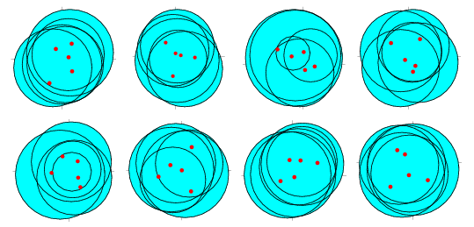
The Gershgorin circle theorem (where "Gershgorin" is sometimes also spelled "Gersgorin" or "Gerschgorin") identifies a region in the complex plane that contains all the eigenvalues of a complex square matrix. For an matrix , define
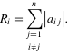 | (1)
Then each eigenvalue of is in at least one of the disks
(2)
The theorem can be made stronger as follows. Let be an integer with , and let be the sum of the magnitudes of the largest off-diagonal elements in column . Then each eigenvalue of is either in one of the disks
(3)
or in one of the regions
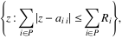 | (4)
where is any subset of such that (Brualdi and Mellendorf 1994).

